

Laptops Price Prediction
MECHINE LEARNING FUNDAMENTALS

Alliance University
Department of Computer Applications
Dataset: Laptops Price Prediction Dataset (data.csv)

Student Name : kumar sai.v
Register No : 2511021240060
Course : BCA
Academic year: 2026-2027

Introduction
This project focuses on analyzing the factors that influence laptop prices using real-world laptop data. The dataset was cleaned and prepared by handling missing values, identifying and treating unusual values, encoding categorical variables, and scaling numerical features.

Methodology
Data loading:
The CSV file is loaded using pandas. The index-like Unnamed: 0 column is removed because it does not represent a laptop characteristic.
Missing-value analysis and mean imputation:
The supplied dataset contains 0 missing cells. The program nevertheless includes mean imputation for numerical variables as required. Because no numerical values are missing, imputation does not alter the supplied observations.
engineering:
RAM is converted from text such as 8GB into Ram_GB, Weight is converted into Weight_kg, and screen-resolution text is separated into Screen_Width and Screen_Height.
Outlier analysis:
The IQR rule is applied to Inches, RAM, Weight, screen dimensions and Price. Observations outside Q1 - 1.5×IQR or Q3 + 1.5×IQR are treated as outliers.
Outlier removal:
Using the combined IQR rule, 331 rows are removed and 972 rows remain for modelling. Label encoding:
Categorical variables are converted into numerical labels using Label Encoder so they can be included in the required regression workflow.
Correlation analysis:
A correlation matrix is calculated to study linear relationships between analytical variables and Price.
Outcome proportionality:
Laptop prices are grouped into six price ranges and their counts/percentages are examined to understand the distribution of the target. Scaling: Min-Max normalization transforms features to a common range, while standardization transforms features to zero mean and unit variance. The standardized features are used for Linear Regression.

Regression:
The cleaned data is divided into 80% training and 20% testing data using random_state=42. Linear Regression is fitted on the standardized training variables.

Python Code

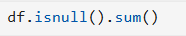
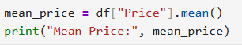
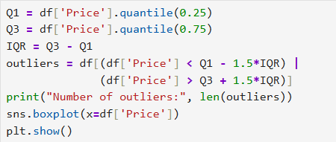
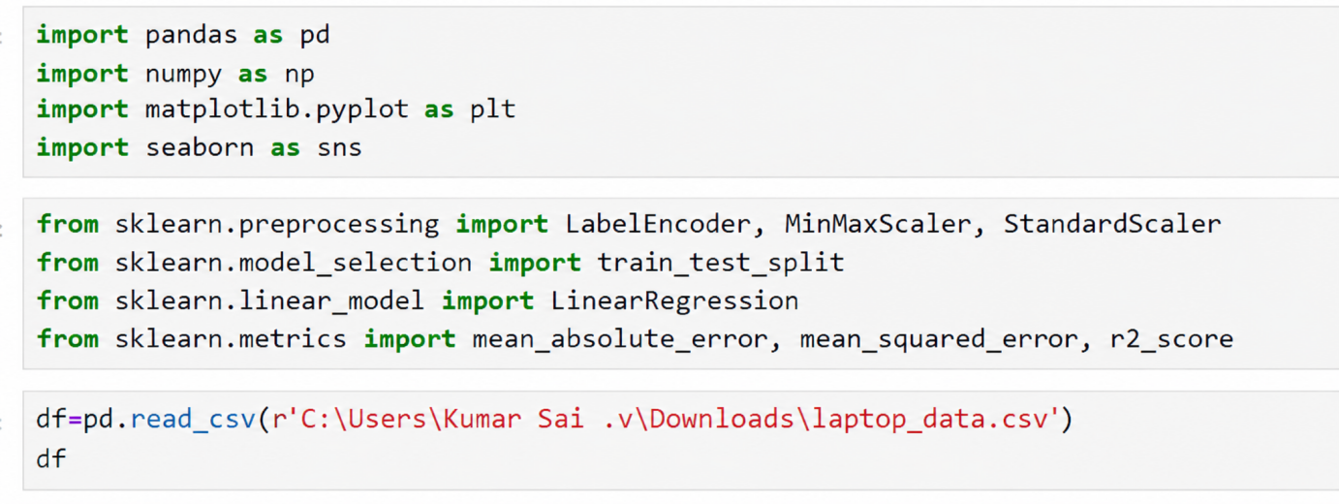

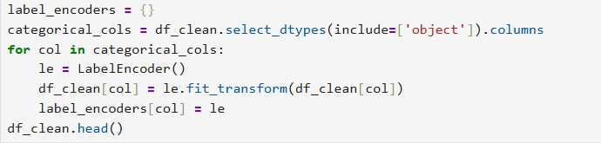

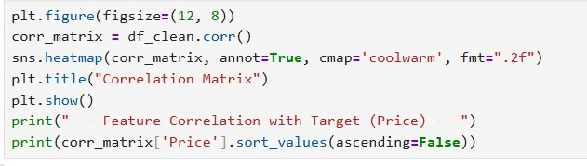
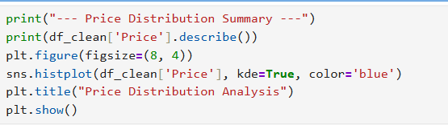
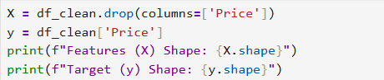
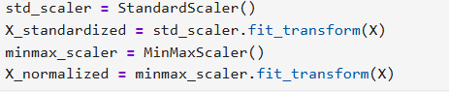
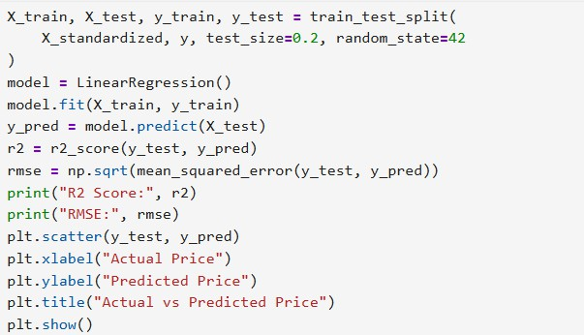

Output and Results
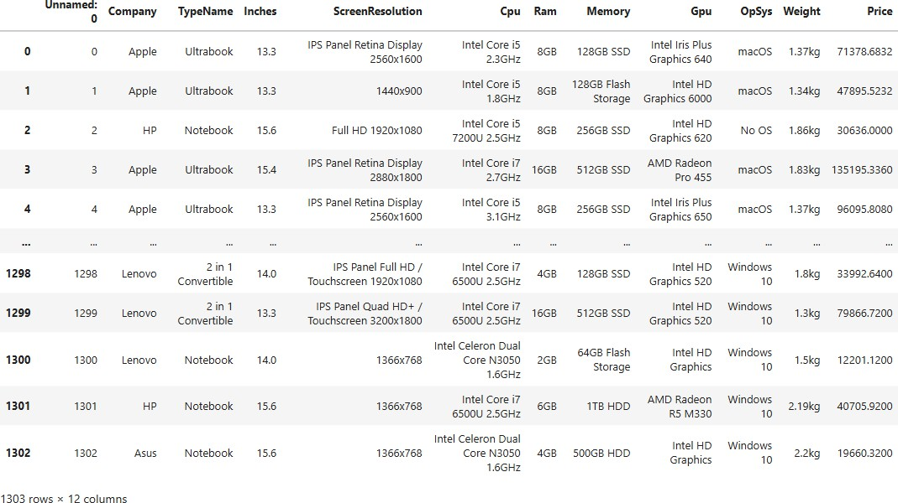
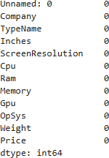

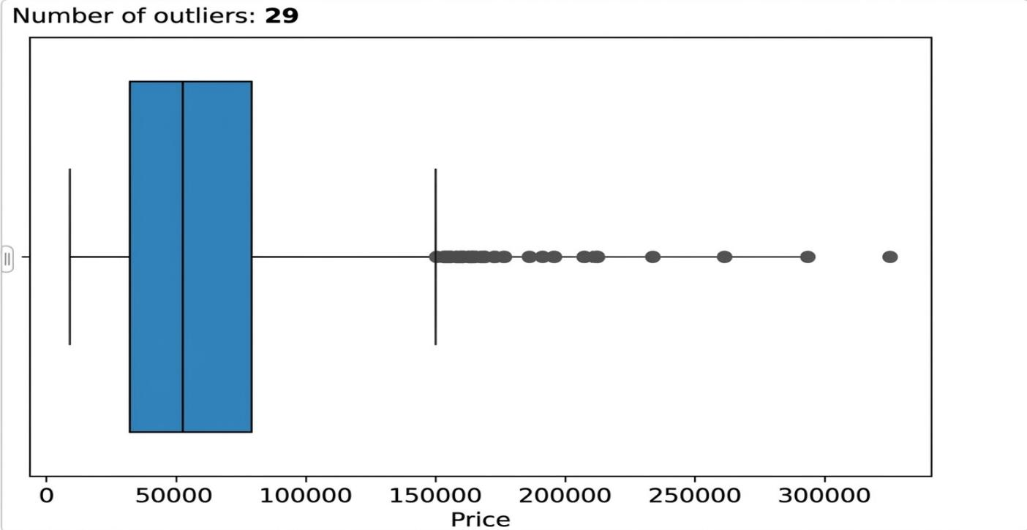

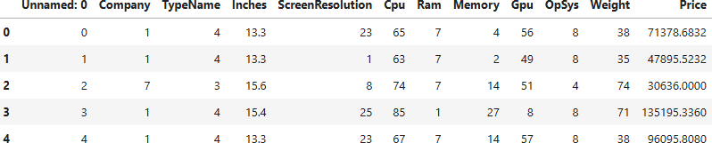

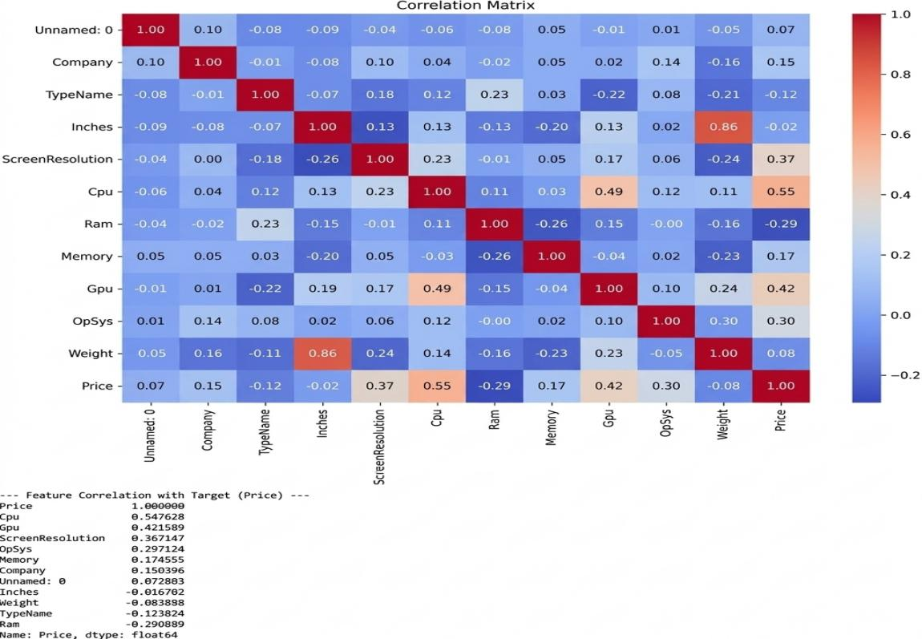

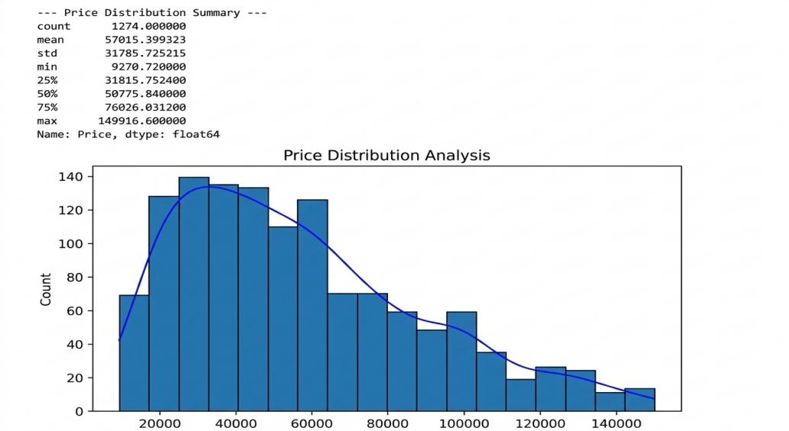
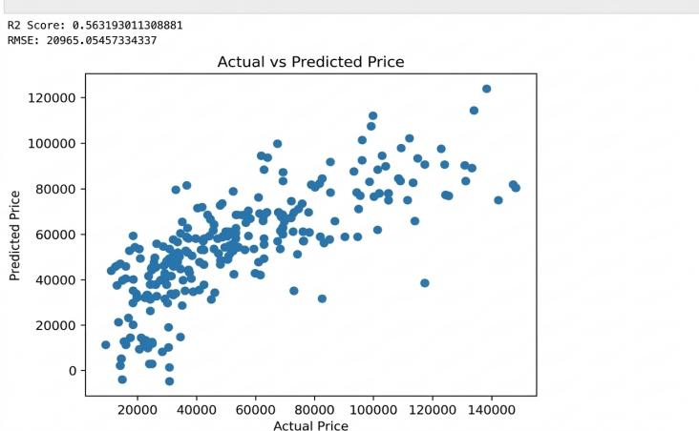

Analysis and Explanation
The dataset has no missing cells and no duplicates. Mean-imputation logic is included as required. The IQR process removed 331 rows and retained 972 for modelling. Ram_GB has a positive correlation of approximately 0.574 with Price. Other variables, including CPU and
screen dimensions, also show positive associations. Correlation should be interpreted as association rather than causation. The Linear Regression model achieved R² = 0.5666 and RMSE = n15,991 on the test set. The model therefore captures a meaningful portion of price variation, but prediction errors remain. Label encoding was used because the assignment explicitly requires it. Since label encoding gives categories integer codes, the regression results should be interpreted with this methodological limitation in mind.

Insights and Findings
→The dataset contains 1,303 laptop records covering multiple brands, device types and hardware configurations.
→RAM is positively associated with laptop price in the processed dataset (correlation » 0.574).
→The largest price category by count is '25K–50K' with 400 laptops (41.15%).
→Outlier removal reduced the modelling dataset by 331 records, which is 25.4% of the original analytical rows.
→The regression model explains approximately 56.7% of the variance in test-set laptop prices according to R².
→The actual-versus-predicted plot shows the degree of alignment between observed and model-estimated prices.

→The project demonstrates the full data-preparation-to-regression workflow required in the assignment

Conclusion
The laptop price project successfully implements all required preprocessing and Linear Regression stages. The model achieved R² = 0.5666 on the held-out test data. The analysis demonstrates that laptop specifications contain useful information for price prediction and provides a complete, reproducible Python workflow

